KNOW

IT

BEFORE YOU VOTE

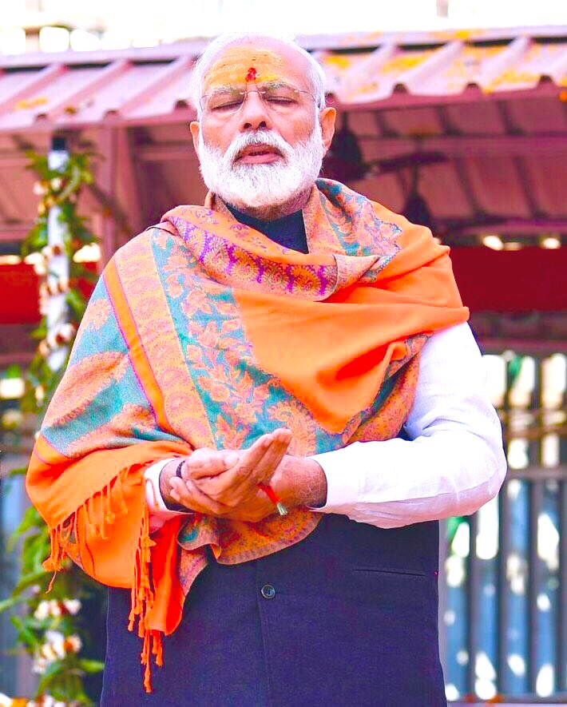

This man is looking to change India. We could call him as as buva or Baba. He has not kept any kind of dignity to his position or power

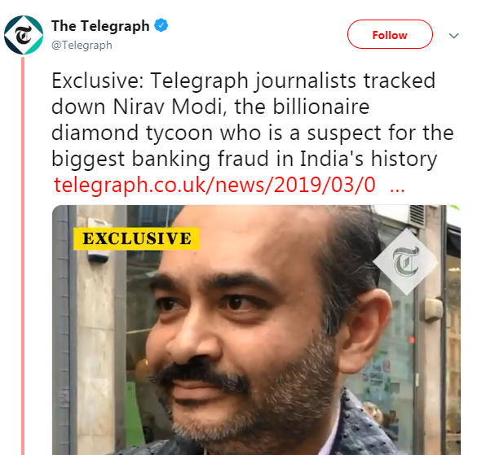

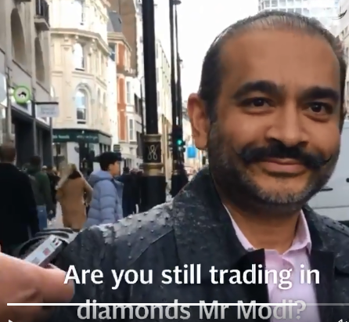

<https://www.telegraph.co.uk/news/2019/03/08/exclusive-indias-wanted-man-nirav-modi-accused-15bn-fraud/>

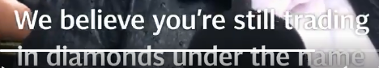

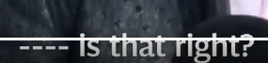

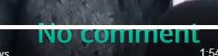

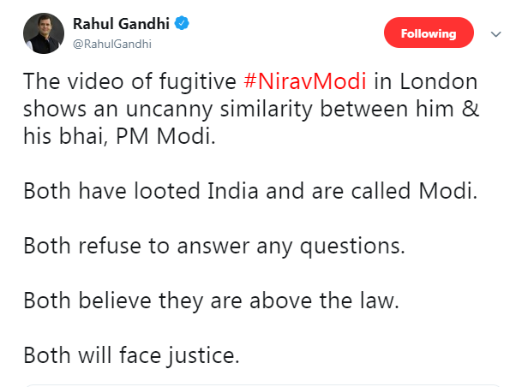

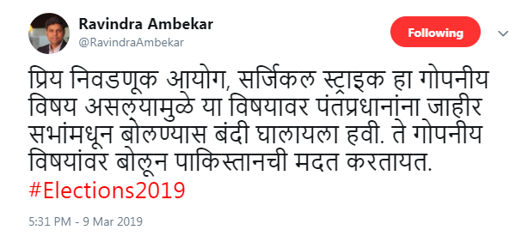

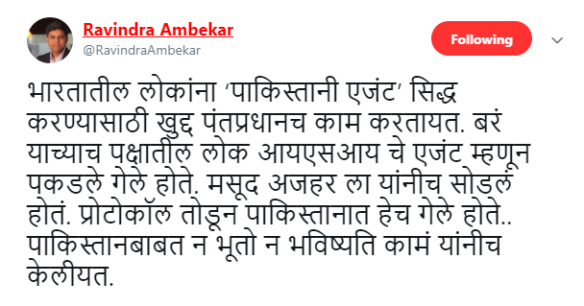

एका खासदाराला ५ वर्षांमध्ये आपल्या मतदारसंघात तब्बल २५ कोटी रुपयांचे कामे फक्त एकट्या खासदार निधीतून करता येतात.. (बाकी विविध योजनांमधून मिळणारा निधी वेगळाच अस्टर) काही खासदार इतके आळशी असतात की ते दिलेल्या निधीचा उपयोगही करत नाहीत.. बघा कुणाकुणाला निवडून देतोय आपण

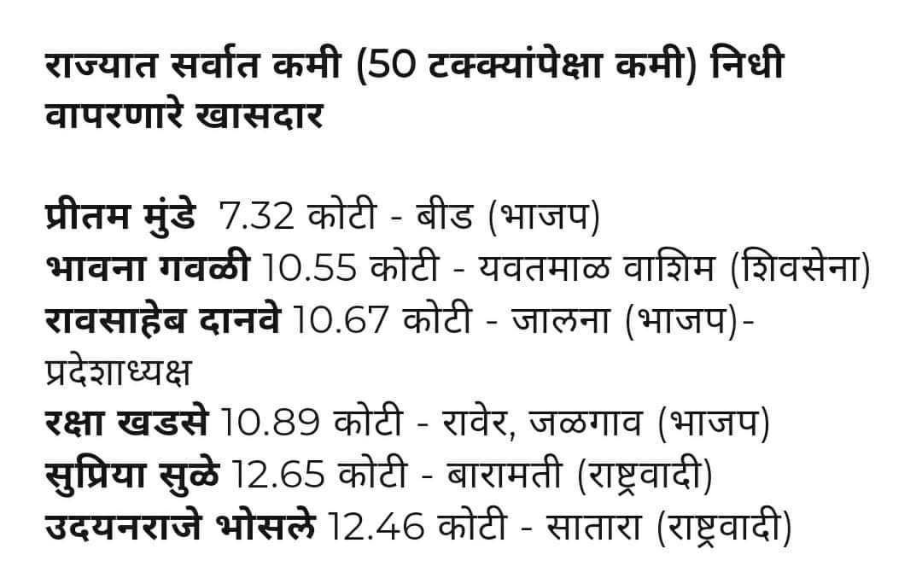

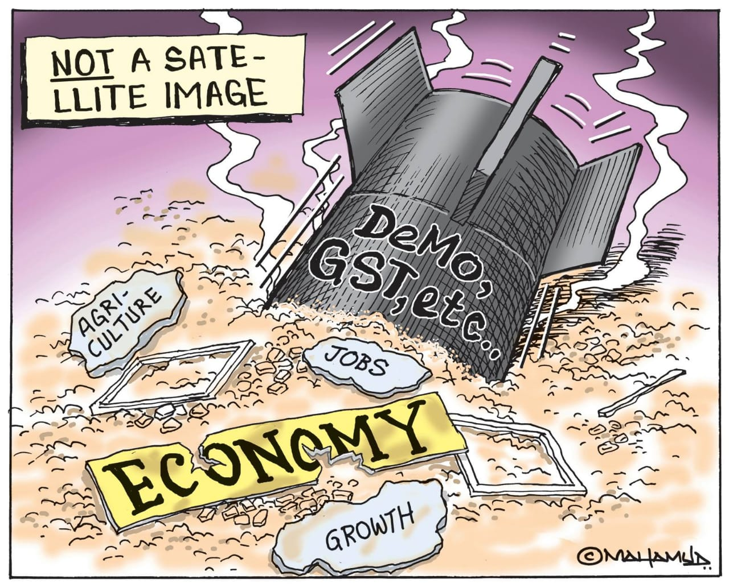

<https://twitter.com/RanaAyyub/status/1104253481907441665>

Anil Ambani’s Company Wins Rs 648 Crore Contract to Build New Airport in Gujarat’s Rajko

<https://twitter.com/_YogendraYadav/status/1104327810678771712>

Dear Election Commission of India: Is this permissible? Using photograph of a serving soldier in political posters? If not, will you act against it?

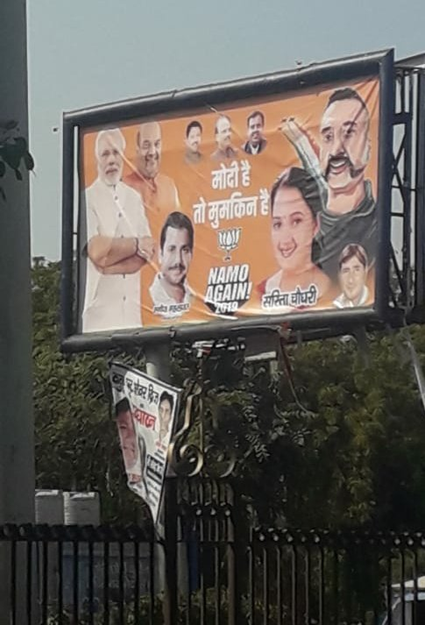

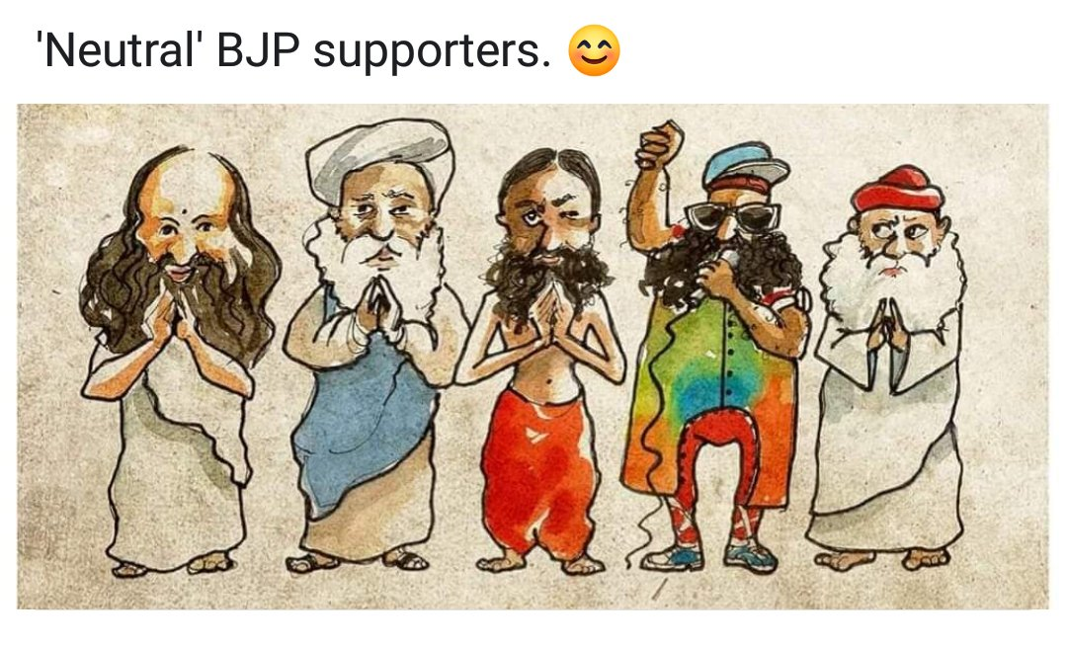

<https://twitter.com/sid21g/status/1104335212706578433>

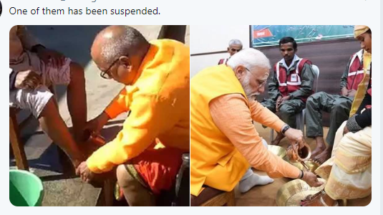



<https://twitter.com/manojkjhadu/status/1104219793413017605>

The Nazis created a large new institution, the Reich Ministry for public Enlightenment and Propaganda to build Anti-Semitic Consensus. In our context this job is being done by more than willing TV anchors and channels.